
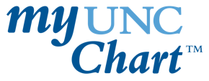
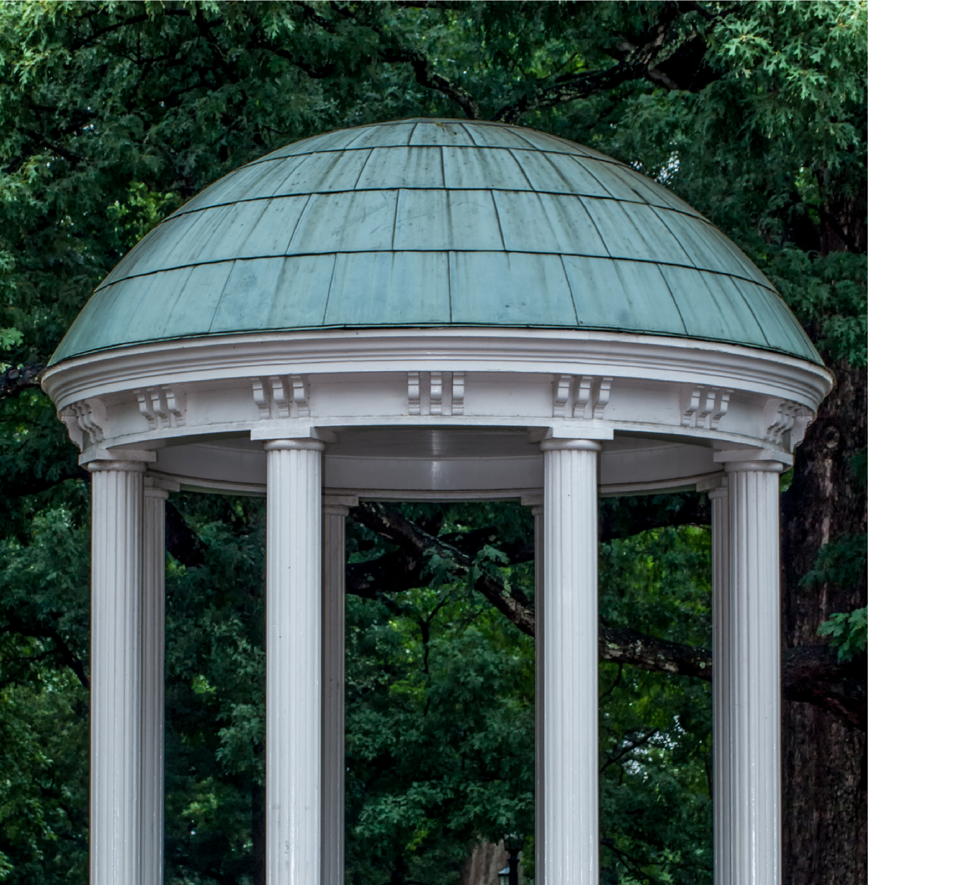
A collaboration between:
- NC TraCS Institute
- UNC Health Epic Research Team
- UNC Health Patient Communications

Messaging Guide for Researchers

MyChart Recruitment Service

FAQs about MyChart Recruitment Messaging
What is the MyChart Recruitment Service?
The Carolina Data Warehouse for Health (CDW-H) at the North Carolina Translational and Clinical Sciences (NC TraCS) Institute, UNC Health Epic Research Team, and UNC Health Patient Communications have partnered to give UNC research teams a way to recruit patients by contacting them through My UNC Chart (MyChart).
With this method, researchers can identify patients who are likely eligible based on electronic medical record data and reach out through UNC Health’s secure, electronic patient portal.
Does it cost to use the MyChart Recruitment Service?
There is a fee assessed for all MyChart recruitment requests. Cost depends on project complexity. CDW-H rates will apply. For current rates, visit the NC TraCS rates page. For specific questions related to rates, please contact NC TraCS: nctracs@unc.edu.
How can our study team get started?
Request a consultation with an NC TraCS CDW analyst to review your options.
[Link to request CDW consultation]
Are there requirements to what the MyChart message can say to patients?
Yes, the messages that are sent via the patient portal – My UNC Chart – must meet particular requirements. This researcher guide was created to help you write your patient recruitment message with these requirements in mind. The message will go through a review process in addition to the IRB approval.
For IRB approval, the patient message will need to be on the MYCR messaging template. You can access the required MyChart recruitment messaging template through the OHRE templates/resources page.

MyChart Messaging Checklist for Researchers

What are the requirements of the messages being sent to patients?
The subject line sparks interest but does not contain sensitive diagnoses or coercive language.
The message is written in plain language and is in 6th-8th grade reading level. This means it uses familiar words, short sentences, and has a clear, organized structure so the information is easy to understand. This avoids medical jargon.
Contains the purpose of the study, with a clear statement that it is research.
Contains the health condition being studied, if relevant to the audience
Contains basic eligibility criteria (i.e., who can join the study), recognizing that the patient list you will receive from the CDW-H has already narrowed the participant pool.
A concise summary of study activities and the expected time commitment (i.e., what participants will do and how much time it will take, how many visits).
Figure 1. Call to Action Options
Foundation | Message (Bulk Messaging)
If you would like to learn more, please click the “I’m Interested” button below. A member of our research team will contact you. | To learn more or see whether this study may be a good fit, please fill out this form:  [Insert screener link]
If you would like to learn more, please contact us at:
Email: [studyteam@unc.edu]
Phone: [XXX‑XXX‑XXXX]
The significance of the study and the importance of the participant’s contribution (i.e., why a potentially eligible participant should care and why the participant’s role is important.
Include how the participant can get in touch with you (“Call to action”). Researchers must include one of the following options below, after their consult with CDW-H. (Figure 1)
States compensation if appropriate and allowed per protocol.
Uses neutral, person-centered terminology. Wording of message should be sensitive to the health conditions such as pregnancy, weight, diagnoses, etc.).
Uses conditional phrasing (e.g., “you may be eligible,” “may help researchers understand…”) and avoids urgency or confirmed eligibility (e.g. you are eligible).
Does not include statements about how the patient was identified (e.g., “based on information in your medical record”) in the body of the message. A pre-approved disclosure explaining data source and privacy protections is included in the template footer and should not be modified or duplicated.
Other study specific criteria and additional review may apply based on population, study type and sensitivities.

Example 1: A Message That May Not Pass Review

Subject Line:
Research Opportunity: Research Study for Rheumatoid Arthritis

Message Body:
The UNC Rheumatology Division is conducting a research study to evaluate the efficacy of an investigational knee-focused therapeutic intervention for individuals diagnosed with rheumatoid arthritis affecting the knee joint. We are currently seeking participants who meet eligibility criteria.
You may qualify if you:
- Are between 30–60 years of age,
- Have physician-confirmed rheumatoid arthritis with knee involvement, and
- Have experienced knee pain and/or stiffness within the previous six months.
Study procedures include completion of two questionnaires related to pain and mobility, a clinical knee assessment conducted on site, and mandatory participation in an eight-week therapeutic protocol targeting knee function.
Participants will receive compensation of up to $200. Limited transportation assistance may be available at the discretion of the study team.
If you wish to be considered, please indicate your interest. A member of the research staff will contact you if you are determined to be eligible.
Dr. Jane Doe, MD
Division of Rheumatology

Criteria Not Met:
(Based on on checklist criteria)
- Reading level (Flesch-Kincaid score) of 14.5; does not meet the 6th–8th grade reading level checklist criteria.
- Compensation included, though vague and unclear.
- Uses terminology that is not aligned with “neutral clinical and person-centered terminology” criteria.
- Does not meet MyChart Recruitment Service call to actions clearly.

Example 2: A Message That May Pass Review.

Subject Line:
Research Opportunity: Invitation to Learn About a UNC Pregnancy Research Study

Message Body:
Researchers at UNC want to learn more about knee pain related to rheumatoid arthritis. We are looking for volunteers to help us understand whether a new knee-focused therapy program can reduce knee pain and make it easier to move more comfortably in everyday life.
You may be eligible for this study if you:
- Are 30 to 60 years old.
- Have been told by a doctor that your rheumatoid arthritis affects your knees.
- Have had knee pain or stiffness in the past 6 months.
What will I have to do in the study?
- You will complete 2 brief questionnaires asking about your pain and movement.
- We will do a short knee movement check-up at our clinic.
- You will take part in an 8-week knee-focused therapy program for rheumatoid arthritis.
What you may receive:
- Compensation of $25 for each week of the program you complete (up to $200 total).
- Help you get to and from the clinic for program visits (for example, transportation, rideshare vouchers or parking reimbursement), if needed.
If you are interested in learning more, please click “I’m interested,” and a member of our study team will reach out to you.
Your feedback is so valuable. By sharing your experience and trying our program, you can help the future care for people with rheumatoid arthritis knee pain.
Thank you for considering this research opportunity.
Add study team info here in our good message.

Criteria Met:
(Based on checklist criteria)
- Reading level appropriate (6th–8th grade)
- Core eligibility criteria included, like age range, RA diagnosis involving knees, etc.
- States compensation appropriately, including payment amounts and transportation support.
- Uses neutral, person‑centered clinical terminology.
- Bonus: Thanks the patient!

